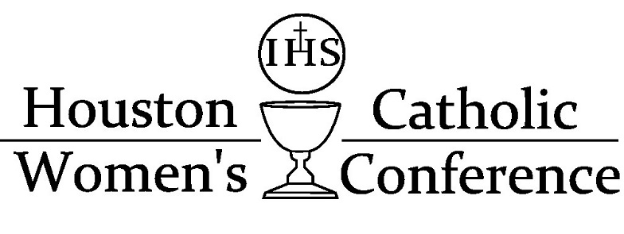

8:15-8:45 Holy Mass in the Church
8:45-10:00 Confession in the Church/Registration opens
10:00-10:15 Opening greeting
10:15-11:15 Talk by Fr. Bart Reynolds
11:15-1pm Open Time- Prayer, Lunch, Shopping
1pm-1:15 Reconvene
1:15-2:15 Talk by Debbie Herbeck- “Fear is useless. What’s needed is Faith.”
2:15-2:45 Door Prizes
2:45-3:45 Talk by Debbie Herbeck-“I am not afraid. I was born for this!”
3:45-4pm Closing, Dismissal

